High Level Design

(eCommerce – Online Cake Order Website)

Revision number: 1.0

Last date of revision: 13/07/2023

**Anshul Maurya**

1

ECOMMERCE – ONLINE CAKE ORDER

# Document Version Control

|  |  |  |  |
| --- | --- | --- | --- |
| Date Issued | Version | Description | Author |
| 13/07/2023 | 1.0 | Initial HLD — V1.0 | Anshul Maurya |
|  |  |  |  |
|  |  |  |  |
|  |  |  |  |
|  |  |  |  |
|  |  |  |  |
|  |  |  |  |

# Contents

Document Version Control 2

Abstract 4

1. Introduction 5
   1. Purpose of the Document 5
   2. Objective of HLD 5
   3. Scope of HLD 5
2. General Description 6
   1. Product Perspective & Problem Statement .6
   2. Proposed solution……………………………………………………………………………………………………………6
   3. Technical Requirements 7
   4. Tools Used 8
   5. Constraints 8
3. Design Details 9
   1. Process Flow 9
   2. Error Handling / Exception Handling 9
   3. Reusability…………………………………………………………………………………………………………………………9
4. Conclusion 10
5. References 13

**Abstract**

The current process of ordering cakes from bakeries is inefficient and time-consuming. Users must either visit the bakery in person or call them to place an order. This can be inconvenient, especially if the bakery is not located nearby. Additionally, the process of placing an order over the phone can be difficult, as users may not be able to clearly describe what they want.

The online cake order website is a web-based application that allows users to browse and order cakes from a variety of bakeries. The website will be developed using a three-tier architecture: the presentation tier, the application tier, and the data tier. The presentation tier will be responsible for displaying the website to users. The application tier will be responsible for processing user requests and communicating with the data tier. The data tier will store the website's data, such as cake images, reviews, and orders.

# Introduction

This document will be used for documenting High-level designs of project.

#### Purpose of the Document

The purpose of this website is such that,

* + - To create a website for online cake ordering and selling.
    - Users will be able to track the status of their orders.
    - Users will be able to browse cakes by category, bakery, or keyword.
    - Secure usage of the components for user and admin.

### Objective of HLD

1. To provide an overview of the entire system.
2. To provide introduction of Problem Perspective & Statement.
3. To provide technical Requirements, Tools used and many more.
4. To provide a module-wise breakup of the entire system.

### Scope of HLD

This HLD covers all areas of system.



# General Description

### Product Perspective

There are various learning courses available on internet but there is often some problems regarding the process of finding those courses. People go to various website searching for a particular courses and this often results in disappointment.

##### 2.2 Problem Statement

The current process of ordering cakes from bakeries is inefficient and time-consuming. Users must either visit the bakery in person or call them to place an order. This can be inconvenient, especially if the bakery is not located nearby. Additionally, the process of placing an order over the phone can be difficult, as users may not be able to clearly describe what they want. The current process of ordering cakes from bakeries is inconvenient for users. They may have to travel to the bakery in person, or they may have to call them and place an order over the phone. This can be time-consuming and frustrating, especially if the bakery is not located nearby. Overall, the online cake order website would be a valuable resource for both users and bakeries. It would solve the current problems with ordering cakes from bakeries, and it would provide several benefits to both parties.

##### 2.3 Proposed Solution

In this project, we are developing a web platform with the proper use of technology and creating a functional website like eCommerce – Online Cake Ordering Website. It will provide products with good convenience and high level of security of data.

The website would allow users to browse cakes from a variety of bakeries, read reviews, and place orders online. This would save users time and hassle, and it would also make it easier for them to find the perfect cake for their needs.

Reach a wider audience and increase sales for bakeries: The website would allow bakeries to list their cakes on the website, and users would be able to find them easily. This would help bakeries to grow their business and reach more customers.

### Technology Requirements

The document addresses the requirement for various technical requirements for the proper usage of various feature of website including the courses and the managing of the user database and smooth process for the instructor to upload the courses. The following technologies have been used-

* + - Firebase for database
    - Express and Nodejs for backend.
    - ReactJs, MUI for frontend.

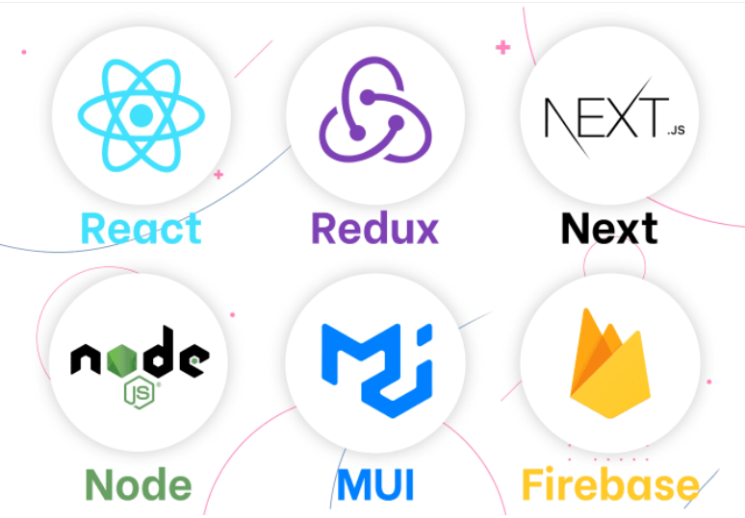

* 1. Tools Used
     1. VS code is used as IDE.
     2. Firestore Cloud from Firebase for data base
     3. Redux for creating multiple states.
     4. Material UI, Tailwind CSS, Framer Motion for UI
     5. Node and Express for Server-side programming.
     6. Stripe for payment gateway.
     7. GitHub is used as version control system.

### Constraints

* + 1. Writing the code in a modular fashion
    2. Safe and testable in many aspects.
    3. Maintaining the code even when it gets complex.
    4. Portable: It works the same in every environment (operating system)
    5. Maintaining the code on GitHub and maintaining the repo on it.
    6. Proper readme file for the project.
    7. Following the code standard and maintaining smooth flow of the system.

1. **Design Details**

### Process Flow

### 3.2 Error Handling / Exception Handling:

There are versions of different technologies which needs to be used correctly. Packages need to be

installed properly. Writing code in such a way so that it doesn’t confuse us. Additionally, we have also dismissed the un-necessary warnings to avoid confusion by using filter warnings class from warnings module.

#### 3.3 Reusability

The code written and the components used should have the ability to be reused with no problems.

1. **Conclusion**

website came out as follows-

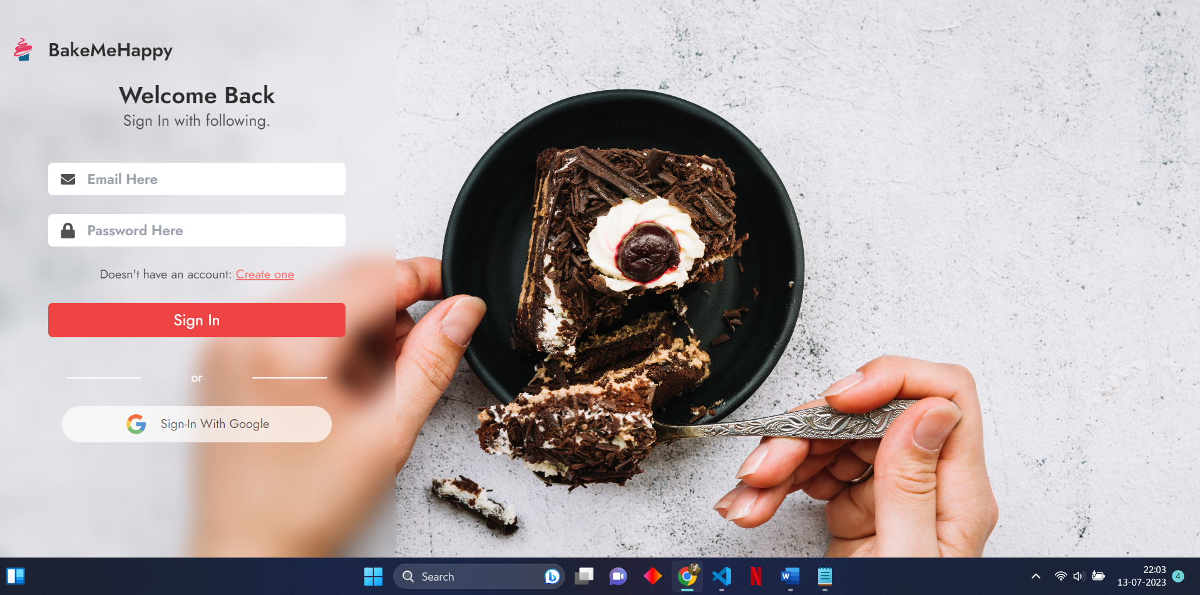

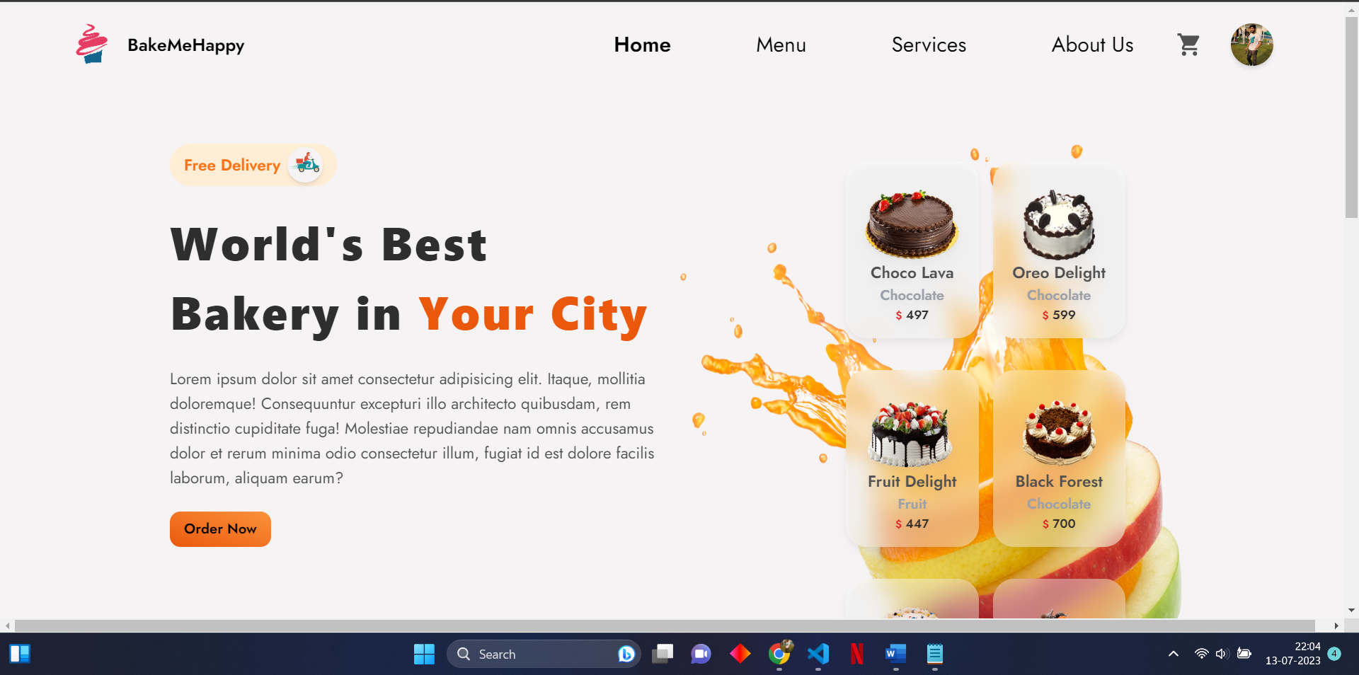

1. **References**
2. <https://legacy.reactjs.org/docs/getting-started.html>
3. <https://www.udemy.com/course/the-complete-react-fullstack-course/?utm_source=adwords&utm_medium=udemyads&utm_campaign=WebDevelopment_v.PROF_la.EN_cc.INDIA_ti.8322_Exp&utm_content=deal4584&utm_term=_._ag_82381207658_._ad_533094292062_._kw__._de_c_._dm__._pl__._ti_dsa-774930029169_._li_9299424_._pd__._&matchtype=&gclid=CjwKCAjw-b-kBhB-EiwA4fvKrAqIZwyvo5cC6QeNwL9EIfpLp_4p9fmmPr4TL1kIIoLOXAXIP3uGwhoCcDEQAvD_BwE>
4. <https://firebase.google.com/docs?gad=1&gclid=CjwKCAjwwb6lBhBJEiwAbuVUSnU5Hyudl7gdj4PnTLp5a75H6QtM3rfQwrlhIWJ5VReNGCfSqsJ2MRoCdAQQAvD_BwE&gclsrc=aw.ds>
5. <https://nodejs.org/en/docs>
6. <https://redux.js.org/>
7. <https://www.framer.com/motion/animate-function/?utm_source=google&utm_medium=adwords&utm_campaign=TW-WW-All-GS-UA-Traffic-20190326-Brand.Bmm_&gad=1&gclid=CjwKCAjwwb6lBhBJEiwAbuVUSpxSTy8P3fgtCtXOtUA49v-Rk5Ui8MPOjqs68LjdoDAypI6OM1L81xoCd3UQAvD_BwE>
8. <https://mui.com/material-ui/getting-started/>